Unit of a long-term plan: 6 Reading for Pleasure |  |  |  | School: Boarding-school of a general type №10
Date: |  |  |  | Teacher name: Aigerim Serdalina
CLASS: 5 |  |  |  | Number present: |  |  | Absent:
Lesson title Summarizing the chosen books

Learning objectives(s) that this lesson is contributing to (link to the Subject programme) |  |  | 5.R5 deduce meaning from context in short texts on a limited range of familiar general and curricular topics  5.R6 recognize the attitude or opinion of the writer in short texts on a limited range of general and curricular topics  5.C9 use imagination to express thoughts, ideas, experiences and feelings
Lesson objectives |  |  | All learners will be able to:
-name the main character from the content of the short story “The Pearl of Kazakhstan”
-identify the main idea of the story “The Pearl of Kazakhstan”
- describe the poster expressing thoughts, ideas, experiences and feelings, using words from the story “The Pearl of Kazakhstan”
 |  |  | Most learners will be able to:
-use topic vocabulary: steep, cheeky, treasure, miserable to explain ideas, thoughts, and feelings about the story “The Pearl of Kazakhstan”
-demonstrate the poster of The Pearl of Kazakhstan to the class
 |  |  | Some learners will be able to:
-compose quatrain about the main character of the short story
-conclude the content of the text and formulate the moral of the short story “The pearl of Kazakhstan”
Assessment criteria |  |  | Figure out the content of the text about Kazakhstan with some support  Identify the attitude and opinion of the author  Convey fantasy ideas including emotions and senses
Language objectives |  |  | Use vocabulary Pictionary from the short story to describe a character
Value links |  |  | Respect for self and others, academic honesty, cooperation, love of native land (Patriotic Act Mangilik Yel)
Cross-curricular links |  |  | Literature, History, Art, Geography
ICT skills |  |  | PPT, interactive board
Previous learning |  |  | Learners read non-fiction books
Plan
Planned  timings | Planned activities |  |  |  |  |  |  | Resources
Beginning  5 min.  Middle  30-35 min | (W) CLASS ROUTINE  Teacher greets students:  Teacher (T): Stand up, please! Attention, please! Good morning!  Students (Ss): Good morning!  T: I’m glad to see you! And what about you?  Ss: (all together, using gestures): We are glad to see you too!  T: Sit down, please! How are you today?  Ss: We are fine, thank you.  T: Very good! Fine! Let’s begin our lesson.  STARTER:  ELICITING (D, W) WARM UP: « Do you like?»  T. invites Ss to stand in a circle. Ss take cards with the question (What do you like reading?). There is an answer on the other side of the card. (I like reading…). Ss should complete the answer with the vocabulary of the previous lessons using types of literature: science fiction, fables, legends etc. S shows their card with the question and asks another one who turns the card with the answer and completes it. Low level Ss can use list of types of literature.  Interaction pattern: T-Ss  SCAFFOLDING: List of types of literature: Learners will be able to answer with the help of the scaffolding by picture  «Big thumb» assessment  INTRODUCTION: «Pass the Parcel»  ELICITING  T. wraps up an object related to the topic in multiple layers of wrapped up paper. Ss. pass the parcel around the classroom whilst the music is playing. Ones it stops the S. removes one of the layers. In each layer add questions related to the topic that the learner should respond before the parcel can be passed around again. When Ss answer the last question they find an object and determine its connection with the lesson. The T. uses the following questions:  -Name six continents of the earth?  -Name your country?  -Name the continent where Kazakhstan is situated?  -Name the part of Kazakhstan where you live?  -Name five cities of the northern part of Kazakhstan?  -The name of our district is…  -Name the land of wonderful songs and poetical legends, the most beautiful corner of Kazakhstan.  Interaction pattern: T-Ss  Oral assessment  The T. encourages Ss. using following words: good job, excellent, well done, clever boy, etc.  The T. introduces Ss the objectives of the lesson  - to figure out new words from the short story  - to identify the idea of the short story “The Pearl of Kazakhstan”  - to create a poster of “The Pearl of Kazakhstan”  DEVELOPMENT  TEAM DIVISION (the name of the short story in three languages)  Ss are divided into 3 groups; 1 group - “The Pearl of Kazakhstan”, 2 group – “Қазақстанның маржаны”, 3 group – “Жемчужина Казахстана  DRILLING (G) THE PEARL OF KAZAKHSTAN. INTRODUCTION OF NEW VOCABULARY  Pre-reading  T. hands out the picture of dictionary for each S. Ss should try to guess the meaning of the words through the pictures: cheeky, wise, steep etc. More motivated learners can support less motivated learners while working on their picture vocabulary. The T. gives the correct pronunciation of the new topic vocabulary. Ss. Practice to pronounce the topic vocabulary, first individually and then in chorus after the T. Interaction pattern: T-Ss  Scaffolding: picture vocabulary  Assessment: stickers-Smiles  The T. gives Ss smiles for each right answer.  While-reading  Learners start reading the first passage of the short story “The Pearl of Kazakhstan”. While reading the short story T. gives the task to name the main hero and identify the main idea of the passage. Ss in groups can demonstrate and compare the main character with the others who has similar features. Some Ss in groups are able to compose a short poem about the main character.  Interaction pattern: Ss-Ss  Descriptors: a learner:  -names the main character of the short story  -identifies the idea of the passage  -demonstrates the main character  -composes quatrain about the main character  Differentiation: by ability of groups  Peer assessment: «Two stars and one wish»  All groups share with their opinion about how they succeed about the task.  (G) MATCHING «GRAPHIC ORGANISER»  Ss read the second passage of the short story. Then T. asks Ss to complete the graphic organiser with the adjectives the writer uses in the story.  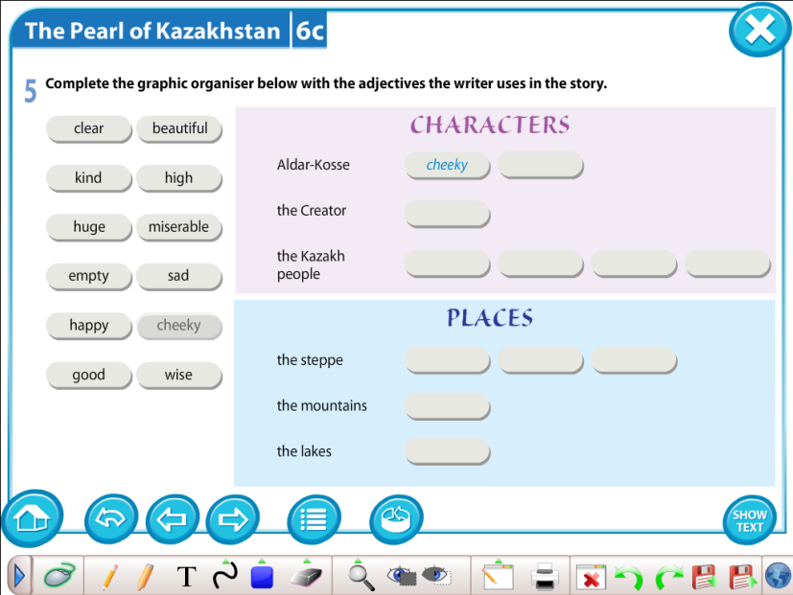  Interaction pattern: Ss-Ss, T-Ss  Descriptors: a learner:  -tells and recognizes new words (adjectives) from the story  -completes the graphic organizer with adjectives according to the writer’s description  Differentiation: by supporting with picture vocabulary  Peer assessment by «Traffic lights cards». After checking the task the T. asks groups to assess each group. Ss raise traffic light cards: red-be careful, yellow-on the right way, green-Go! Well done.  Post-reading  (G) «Creation a poster of The Pearl of  Kazakhstan»  The T. gives the tasks to create own «The Pearl of Borovoy»  CRAFTWORK. Interaction pattern: Ss-Ss, T-Ss  Descriptors: a learner:  -discusses the idea  -gives the title for the work  -uses lesson topic vocabulary  -designs of the poster will be considered  -prepares the presentation of the work  -concludes the information of the text and formulate the  moral of the short story “The pearl of Kazakhstan”  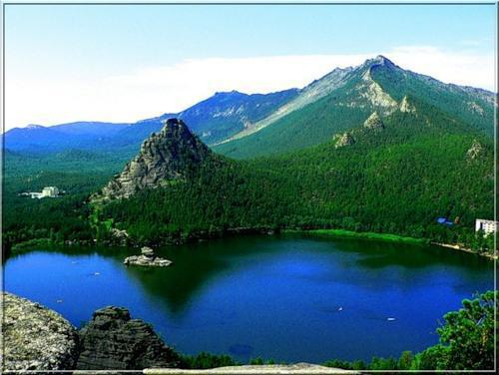  Peer assessment: «Fist of five» assessment. The T. asks groups to assess each other.  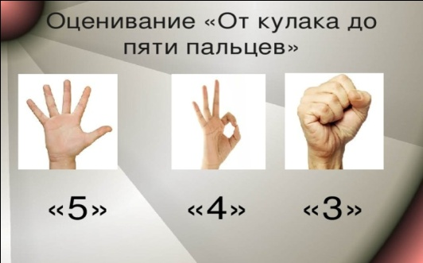  The T. asks Ss to show five fingers to those who makes all the tasks correctly; three fingers to those who fulfills the most of the tasks; fist is for those who does of tasks |  |  |  |  |  |  | PPT  Slides (1-5)  Cards  What do you like reading?  I like  reading…  reading…  Flat box with pearls wrapped in paper    PPT-(6 slide)  Box and papers with names of groups  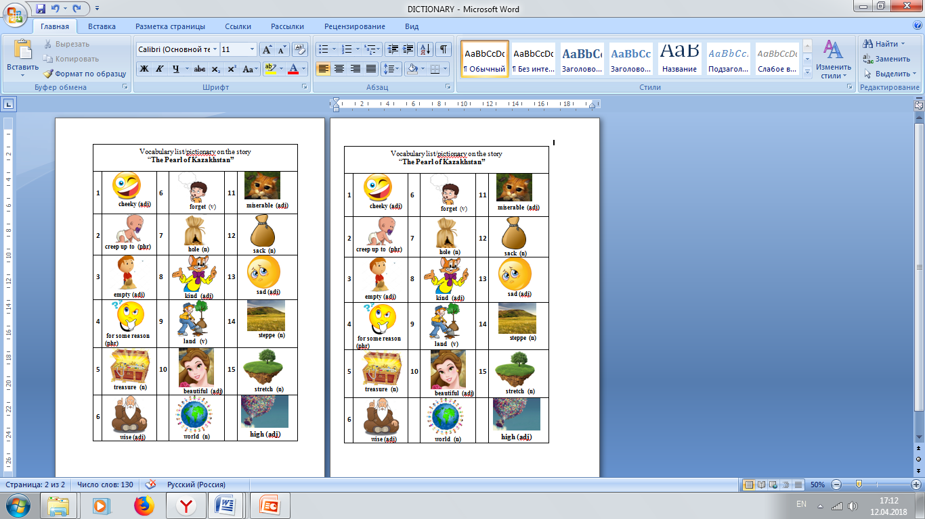  Handout-Short story “The pearl of Kazakhstan”  Graphic  (Characters,  places)  Handout-Short story “The pearl of Kazakhstan”  Traffic lights cards    Posters, colour pencils, glue, scissors, additional material: zhumbactas, craps of trees, lakes, mountains.
2 min | (W) PLENARY: «5-5-1»  Ss write five sentences about what they have learnt during the lesson. Next they reduce their five sentences to five words. Finally they reduce their five words to one word. Learners share their key words with the whole class.  Interaction pattern: T-Ss  Descriptors: a learner:  -Writes 5 sentences  -Chooses 5 words from these sentences  -Concludes 1 word from 5 words  -Shares their key words with the whole class.
3 min | (W) CLASS ROUTINE. REFLECTION.  The T. returns to the objectives of the lesson and asks Ss to analyze their work in groups, have they achieved the lesson objectives or had they some problems. The T. puts on the blackboard a picture of the mountain imitating the ladder of success. The T. asks Ss to stick the key words on the signed stairs:  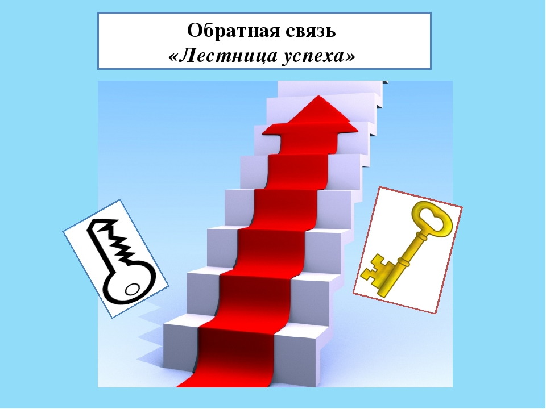  I did not succeed  I had some problems  I have succeeded in all  The T. says that the lesson is over and thanks Ss for participating at the lesson. T. make group photo with their posters. |  |  |  |  |  |  | Magnets  Picture of the mountain
Additional information
Differentiation – how do you plan to give more support? How do you plan to challenge the more able learners? |  |  |  |  | Assessment – how are you planning to check learners’ learning? | Health and safety check  ICT links  Values links
-More support can be given in the middle of lesson by providing less-able learners with picture vocabulary in a word list so they can see pictures of them.  -Differentiation by group ability:  -less-able learners name the main character of the short story, identify the idea of the passage  -more-able learners demonstrate the main character, compose quatrain about the main character  -More motivated learners can support less motivated learners while working in groups.  -Differentiation by teacher support  -Differentiation by difficulty of task  -less-able learners discuss the idea, give the title for the work, use lesson topic vocabulary, design the poster of “the pearl of Kazakhstan”,  prepare the presentation of the work  more-able learners conclude the information of the text and formulate the moral of the short story “The pearl of Kazakhstan” |  |  |  |  | -Monitoring  - «Big thumb» assessment  -Oral assessment  - Smiles  - Peer assessment: «Two stars and one wish»  by «Traffic lights cards»  «Fist assessment». | -Positive emotional attitude in the classroom  -Optimal pace of the lesson  -Material supply in an affordable and rational way  -Change of activities ( read, speak, think, reason, match, create, paint)
Reflection  Were the lesson objectives/learning objectives realistic?  What did the learners learn today?  What was the learning atmosphere like?  Did my planned differentiation work well? |  | Use the space below to reflect on your lesson. Answer the most relevant questions from the box on the left about your lesson.

